**Question: 01 Design circuit diagram in Logic Works given expressions by using NAND gates**

**only**

1. **ABC + D' + E'**

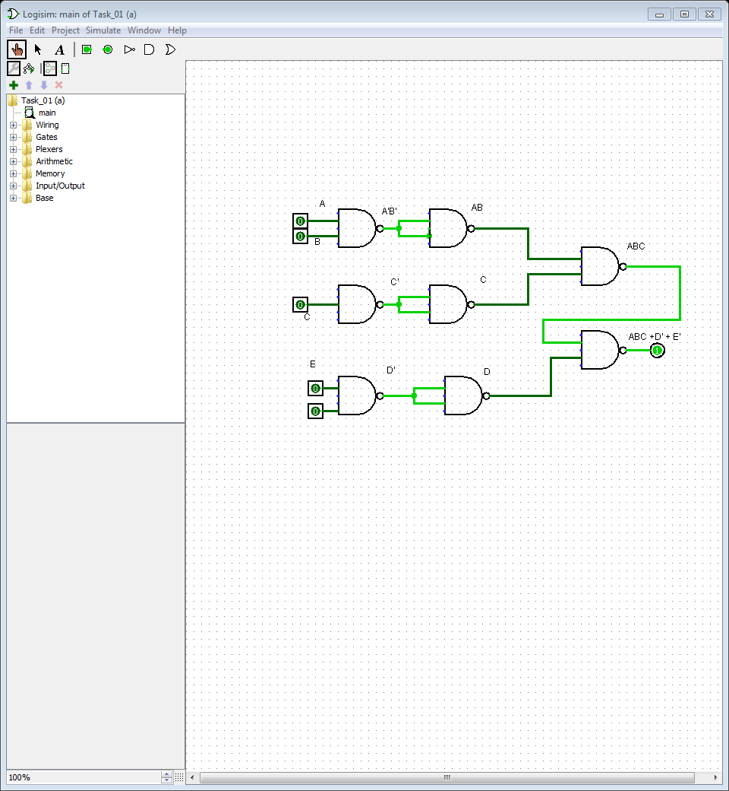

1. **ABC + DE**

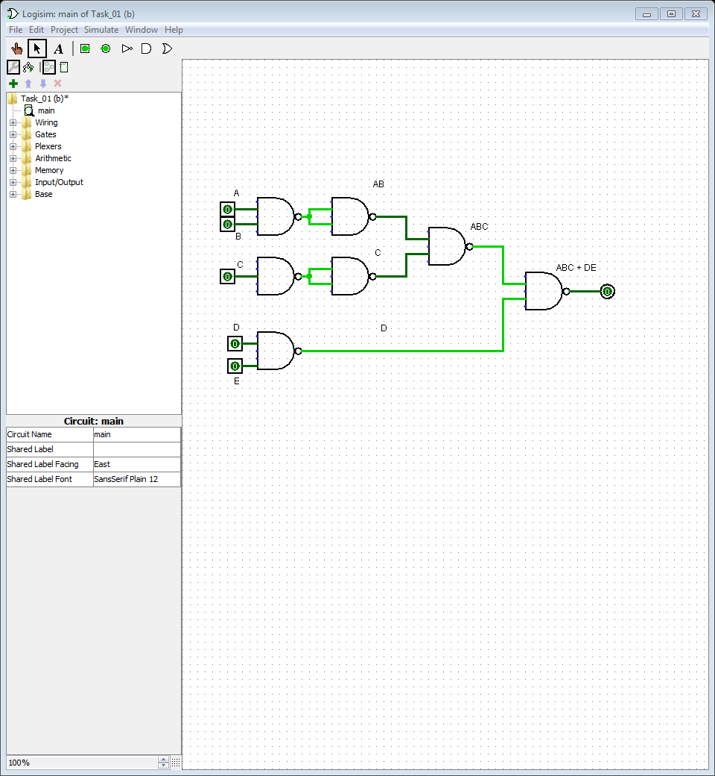

**Question: 02**

**simplify the following Boolean expression: and design circuit in Logisim/Logic Works.**

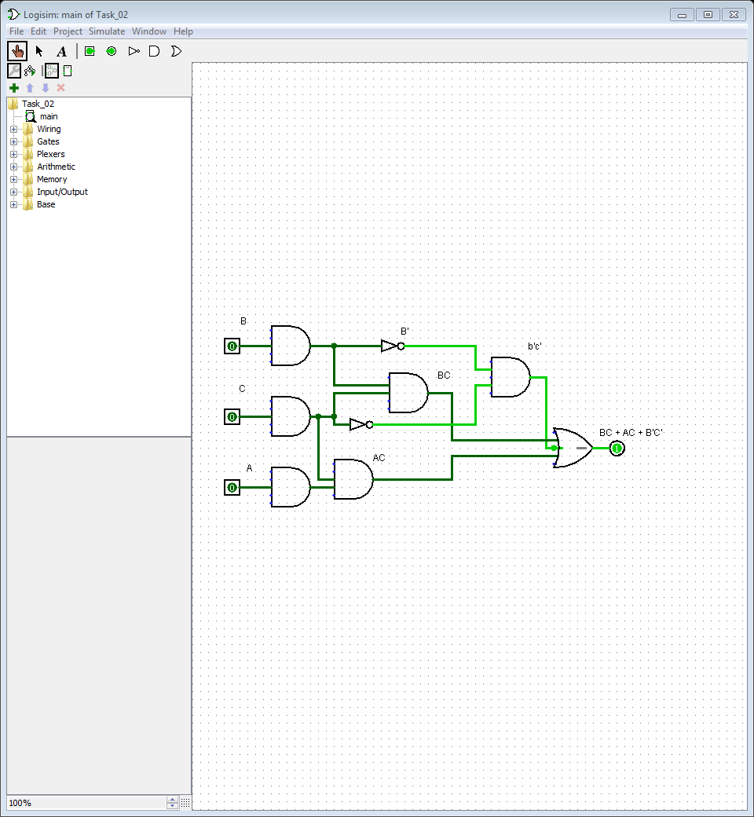

**Question: 03**

**a. Group the 1s in each of the Karnaugh maps in Figures**

**b. Determine the product terms for each of the Karnaugh maps in Figures and write the resulting minimum SOP expression on Logisim/Logic Works.**

**PART – A:**

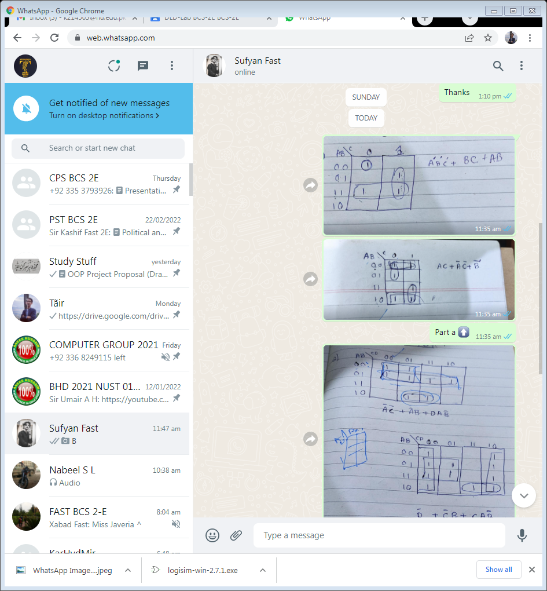

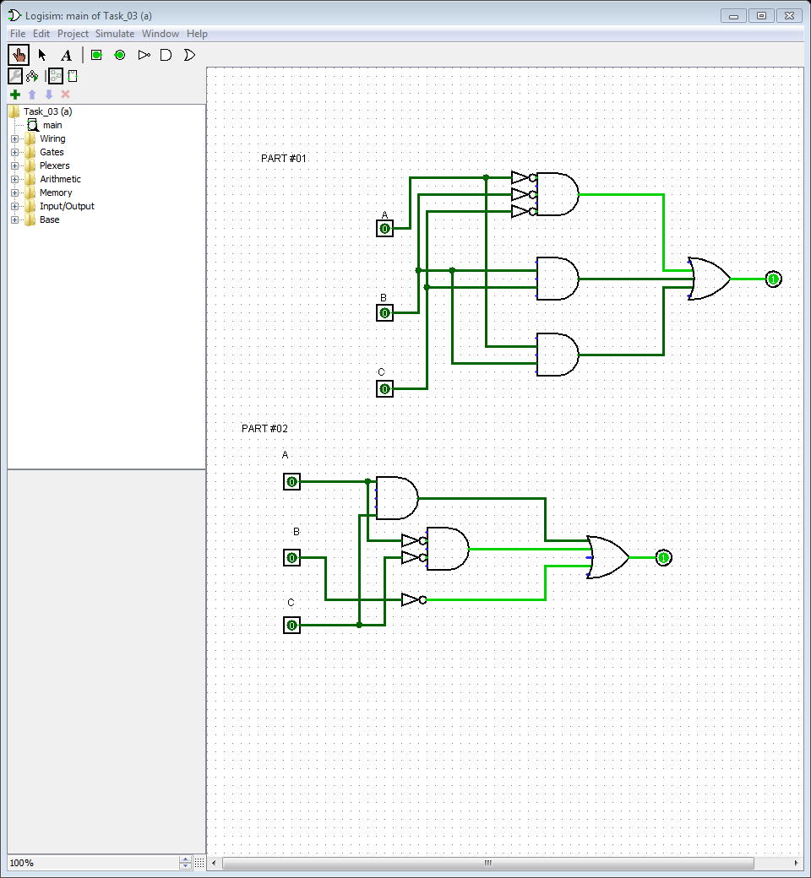

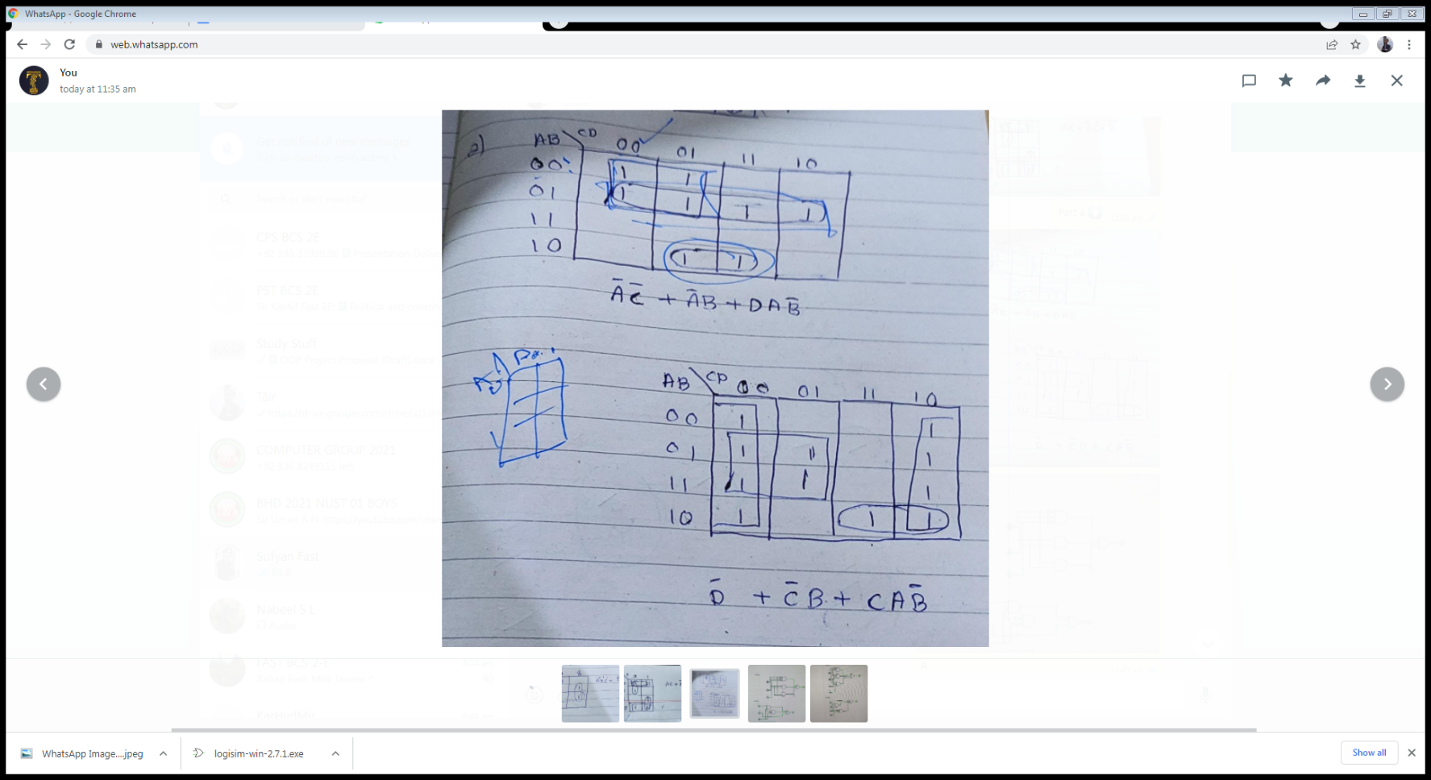**PART – B:**

